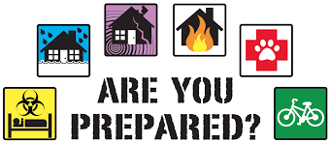Sanpete Emergency Awareness Fair
Saturday May 14, 2015
11am – 2pm
All ages welcome
Mt Pleasant City Park
Know what to do in case of an Emergency

Helicopter,
Ambulance, Fire Dept, Police,
Hospital
First Aid Classes –
Earn your Merit Badge

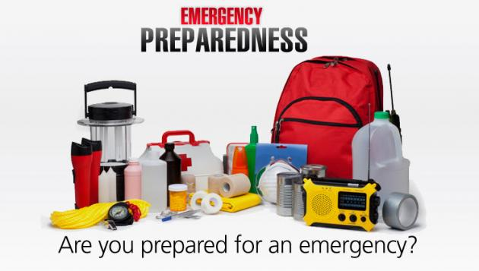

Learn CPR
Drawing
Splinting
Drug Awareness:
How to recognize signs of drug use
Learn to lift and move people safely in emergencies
Hot dogs & Drinks
Earthquake Safety
Suicide Prevention Info
Bleeding control
INFORMATION BOOTH

Diabetic Emergencies
Learn when to call 911

